**ST.XAVIER’S COLLEGE**

MAITIGHAR, KATHMANDU



Computer Graphics

Assignment #7

Submitted By:

Dikita Tuladhar

013BSCCSIT018

2nd year/ 4th semester

Submitted to:

|  |  |
| --- | --- |
| Er. Anil K. Sah  Lecturer  Department of Computer Science |  |

Date of Submission: 1st September,2015

**STATEMENT: “IMPLEMENT TRANSLATION, ROTATION AND SCALING ALGORITHM IN C++ BUILDER”.**

**SOURCE CODE:**

//---------------------------------------------------------------------------

#include <vcl\vcl.h>

#pragma hdrstop

#include <math.h>

#include "transformation.h"

//---------------------------------------------------------------------------

#pragma resource "*.dfm"

TForm1 *Form1;

//---------------------------------------------------------------------------

__fastcall TForm1::TForm1(TComponent* Owner)

: TForm(Owner)

{

}

//---------------------------------------------------------------------------

void __fastcall TForm1::butTransClick(TObject *Sender)

{

outPanel->Canvas->FillRect(ClientRect);

int i ,j,tx,ty,x,y;

int h = inPanel->Height;

int w= inPanel->Width;

tx= StrToInt(inTx->Text);

ty= StrToInt(inTy->Text);

for(i=0;i<=h;i++){

for(j=0;j<=w;j++){

x=i+tx;

y=j+ty;

outPanel->Canvas->Pixels[x][y] = inPanel->Canvas->Pixels[i][j];

}

}

}

//---------------------------------------------------------------------------

void __fastcall TForm1::inRotateClick(TObject *Sender)

{

outPanel->Canvas->FillRect(ClientRect);

int i,j,h,w;

float x,y;

float angle= StrToFloat(inRo->Text)*(3.1415/180);

h =inPanel->Height;

w= inPanel->Width;

for(i=0;i<=h;i++){

for(j=0;j<=w;j++){

x=(i*cos(angle)- j*sin(angle));

y=(j*cos(angle) + i*sin(angle));

outPanel->Canvas->Pixels[x][y] = inPanel->Canvas->Pixels[i][j];

}

}

}

//---------------------------------------------------------------------------

void __fastcall TForm1::Button1Click(TObject *Sender)

{

outPanel->Canvas->FillRect(ClientRect);

int i ,j,sx,sy,x,y;

int h = inPanel->Height;

int w= inPanel->Width;

sx= StrToInt(Edit1->Text);

sy= StrToInt(Edit2->Text);

for(i=0;i<=h;i++){

for(j=0;j<=w;j++){

x=i*sx;

y=j*sy;

outPanel->Canvas->Pixels[x][y] = inPanel->Canvas->Pixels[i][j];

}

}

}

//-----

**OUTPUT SCREENS:**

**Translation:**

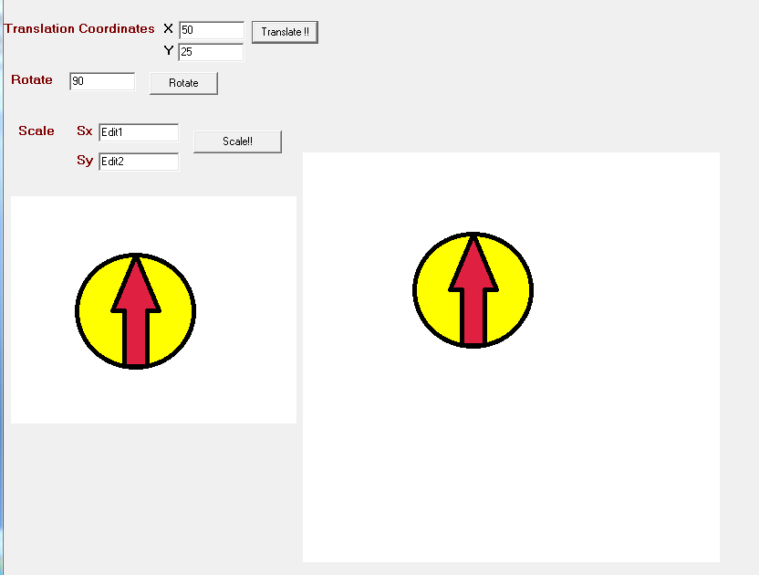

**Rotation:**

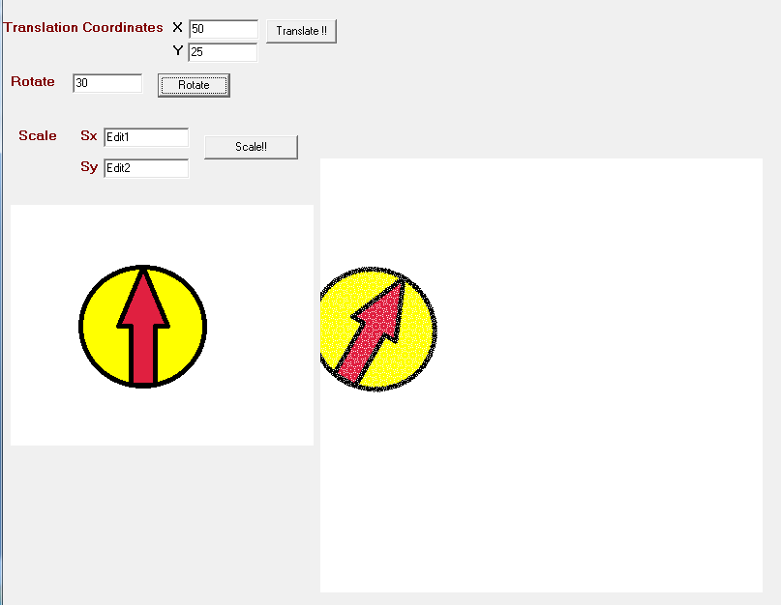

**Scaling:**

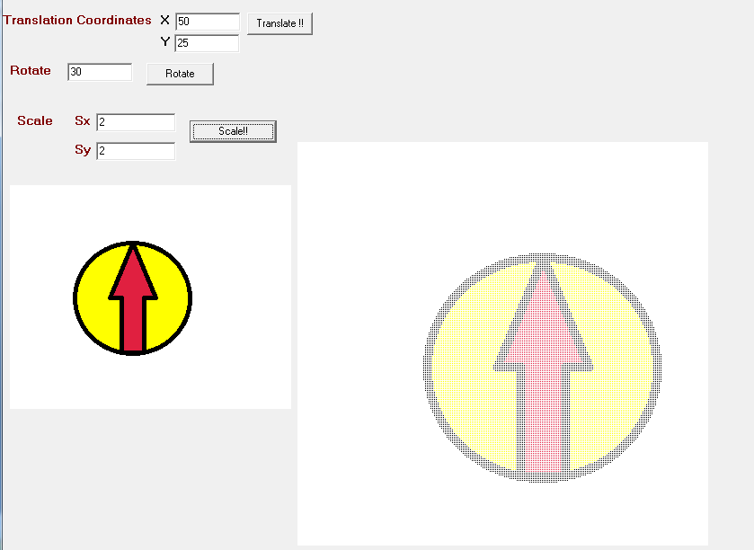

**CONCLUSION:**

Hence, the program to implement translation, rotation and scaling using C++ builder was implemented.